7.2.7 Editors - 3D View - Header - Edit mode menus
Detailed Table of content 1
Edit Mode - Add Menu 1
Edit Mode - Mesh Object - Mesh Menu 1
Edit Mode - Curve + Surface Object - Curve + Surface Menu 15
Edit Mode - Metaball Object - Metaball Menu 18
Edit Mode - Text Object - Text Menu 19
Edit Mode - Armature Object - Armature Menu 20
Edit Mode - Lattice Object - Lattice Menu 27

Detailed Table of content

Edit Mode - Add Menu

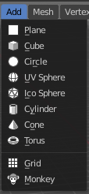
In Edit Mode you will also see a add menu for some object types. The number of objects that you can add is limited to the same object type that you are in edit mode with. You can just add mesh geometry to a mesh geometry. And just curve geometry to curve geometry.

The added objects in edit mode becomes part of the current object geometry.

Edit Mode - Mesh Object - Mesh Menu

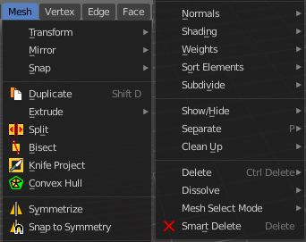
The Mesh Menu in Edit Mode contains the tools to manipulate the mesh geometry in Edit mode. It just exists for Mesh Objects.

Lots of functionality that could also belong here can also be found in the Tool Shelf. The difference is that the tools in the tool shelf are easier to access. And so it contains the most used tools for the daily work. While the Mesh menu contains the not so often used tools. Or tools where you use the hotkey anyway. Delete for example.


Transform

To Sphere
Shapes a selection of objects into the shape of a sphere. The calculation happens with the object origins.
In Object mode this tools requires to have more than one object selected.

Usage

Select the vertices, activate the tool, then drag the mouse in the 3D viewport. In the header you will read the current factor then. Which tells you how close you are towards the sphere shape.



Last Operator Add Ico Sphere Panel

Factor
The factor to transform the selection into a shape form.


Proportional editing
Enables proportional editing. Activating proportional editing reveals further settings.

Proportional Falloff
Here you can adjust the falloff methods.

Proportional Size
Here you can see and adjust the falloff radius.

Connected
The proportional falloff gets calculated for connected parts only.

Projected(2D)
The proportional falloff gets calculated in the screen space. Depth doesn't play a role. When it's in the radius, then it gets calculated.

Shear
Shear shears the selection.


Last Operator Shear

Offset
Here you can adjust an offset.

Shear Axis
The shear tool works along a imaginary 2d plane. The shear axis controls if the itemas are sheared along the x or the y axes of this plane. This is the plane along which the transformation happens. You can shear along the x or the y axis of this plane.
To make things even more complicated, the orientation of this imaginary plane is defined by the Axis and Axis Ortho items below.

Axis
Defines one axis of the imaginary shear axis plane.


Axis Ortho
Defines the other axis of the imaginary shear axis plane.

Orientation
Here you can choose the orientation for the shear action.

Proportional editing
Enables proportional editing. Activating proportional editing reveals further settings.

Proportional Falloff
Here you can adjust the falloff methods.

Proportional Size
Here you can see and adjust the falloff radius.

Connected
The proportional falloff gets calculated for connected parts only.

Projected(2D)
The proportional falloff gets calculated in the screen space. Depth doesn't play a role. When it's in the radius, then it gets calculated.

Bend
Bends the selection.

Push/Pull
It pushes or pulls the object positions relative to the center of the selection.
In Object mode this tool requires to have more than one object selected.


Last Operator Push/Pull

Factor
Here you can adjust the strength of influence of the tool.

Proportional editing
Enables proportional editing. Activating proportional editing reveals further settings.

Proportional Falloff
Here you can adjust the falloff methods.

Proportional Size
Here you can see and adjust the falloff radius.

Connected
The proportional falloff gets calculated for connected parts only.

Projected(2D)
The proportional falloff gets calculated in the screen space. Depth doesn't play a role. When it's in the radius, then it gets calculated.


Warp
Warps a mesh selection between two defined points.

Last operator Warp

Warp Angle
The strength of the warp effect

Offset Angle
A offset angle to bend sidewards.


Min
The start point.

Max
The end point.

Randomize Transform
This tool allows randomizes the positions of the selected vertices.


Last Operator Randomize Transform

Amount
Here you can adjust the amount.

Uniform
The uniform offset distance.

Normal
Align the offset direction to the normals.

Random Seed
The seed value for randomization.

Skin Resize

Mirror


Snap

Smart Delete
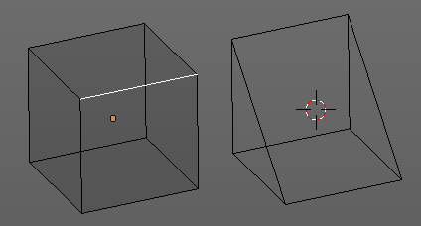
Smart delete deletes what is selected in an intelligent way. When you for example delete an edge then the edge gets deleted. But it also deletes the vertices connected to this edge. It performs a Dissolve operation under the hood.
There is a bit below a Delete menu where you can choose different methods for deleting if required. And the Dissolve tools can be found in the Tool Shelf in the Tools tab.

Show / Hide
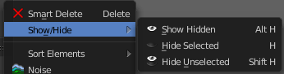
Show / hide is a menu that contains the Show Hide tools. Here you can show or hide your current selection in the viewport. See chapter All Modes, all Object types - Show / Hide

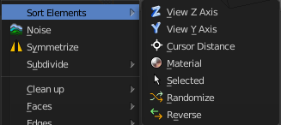
Sort Elements
Sort Elements is a menu with different sorting methods. It allows you to reorder the mesh indices of the selected mesh elements by various methods.

Hint
You can enable the viewing of mesh indices by typing in bpy.app.debug = True in the Python console in the scripting layout. This reveals a checkbox in the Mesh Display panel in the Info Options subsection. And when you tick this checkbox, then the vertices or edges or faces gets displayed with their indices value.
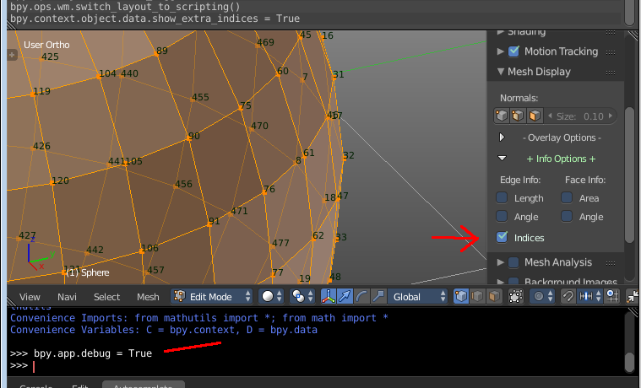

View Z Axis
Sorts along the active view’s Z axis, from farthest to nearest. You can use Reverse if you want it the other way.

View Y Axis
Sorts along the active view’s Y axis, from farthest to nearest. You can use Reverse if you want it the other way.

Cursor Distance
Sorts from nearest to farthest away from the 3D cursor position.

Material
Faces only! Sorts faces by their lowest material index up to highest material index. Order of faces inside each of those material groups remains unchanged.

Note that the Reverse option only reverses the order of the materials. And the order of the faces inside them.

Selected
Moves all selected elements to the beginning without affecting their relative orders. Attention, this option will also affect unselected element indices!

Randomize
Randomizes the indices of selected elements. This option does not affect the unselected elements.

Reverse
Reverses the order of the selected elements.

Last Operator Sort Mesh Elements
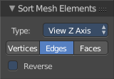
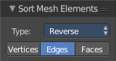
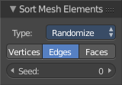
Sort Elements always brings up the same last operator. But with a small difference for Randomize and Reverse. Reverse has no checkbox. And Randomize has a Seed checkbox.

Type
This is a drop-down box where you can choose the sort method again.

Vertices, Edges or Faces
Here you can adjust if the sort will affect the vertices, edges or faces.

Reverse Checkbox
Reverses the sorting.

Seed Edit box (Randomize only)
The seed option allows you to get another randomization – the same seed over the same mesh/set of selected elements will always give the same result!

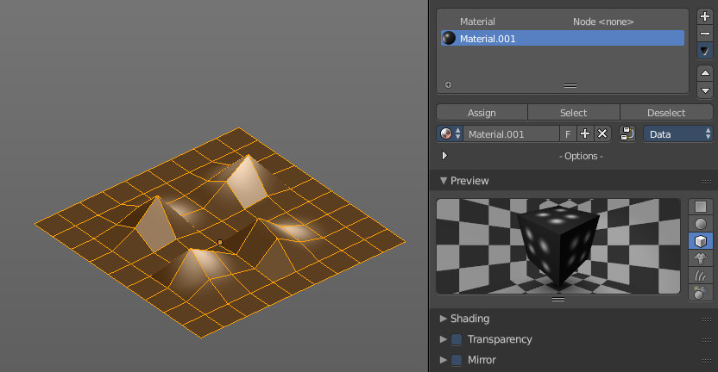
Noise
Noise is a displacement tool where you can use a texture to displace the geometry. It just works with the Blender Internal renderer, and you need to have a texture and a material assigned.
The strength can be adjusted in the Last Operator.

Last Operator Noise

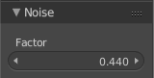
Factor
Here you can adjust the strength of the displacement.

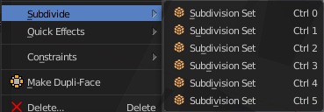
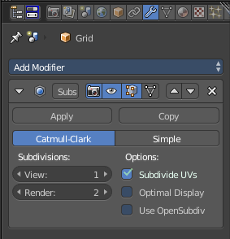
Subdivide
Subdivide is a menu where you can quickly set the subdivision level of the selection.
What it does is to add a SDS modifier in the Properties Editor if required. And set the SDS level to the needed value.
Crtrl 0 sets SDS to level 0. Ctrl 1 sets SDS level to 1 , and so on.
SDS happens at Object mode level. Even when you apply it in the Edit Mode! And it happens at the whole object.

Last Operator Subdivision Set

Level
Here you can adjust the SDS level.

Relative
Applies the Subsurf Level as an offset relative to the current level.

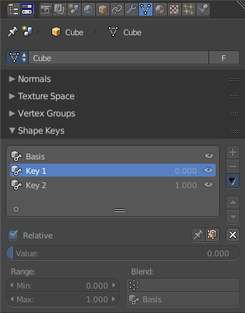
Blend from Shape
This tool requires to have a shape key at the mesh. It blends the selected shape key into the mesh.

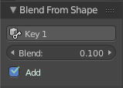
Last Operator Blend from Shape

Drop-down box
Here you can define which shape key should be used.

Blend edit box
Here you can adjust the blend factor

Add
Add to blend shape instead of blending in.

Shape Propagate
This tool requires to have a shape key at the mesh. It applies the current vertex locations to all other shape keys at the mesh.

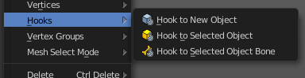
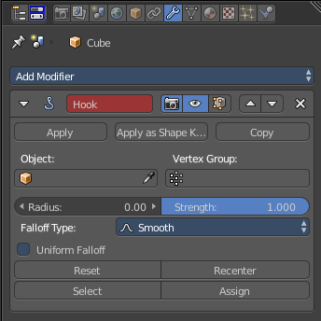
Hooks
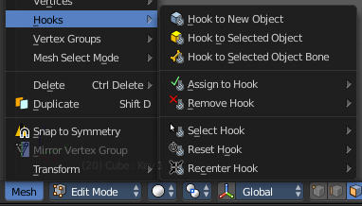
Hooks is a menu with tools around the hook modifier. You could also adjust the hook modifier from the Properties editor. But the menu items are more accessible.
When there is no hook modifier at the mesh then you just see three menu items. When there is minimum one hook modifier applied, then you will see an extended menu.

Hook to New Object
Creates a new Hook Modifier for the active object and assigns it to the selected vertices. It also creates an empty at the center of those vertices, which are hooked to it.

Hook to Selected Object
Does the same as Hook to New Object, but instead of hooking the vertices to a new empty, it hooks them to the selected object (if it exists). There should be only one selected object (besides the mesh being edited).

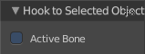
Last Operator Hook to Selected Object

Active Bone
Hook to the object(s) of the active bone.

Hook to Selected Object Bone
Does the same as Hook to New Object. But it sets the last selected bone in the also selected armature as a target.

Assign to Hook
Here you can assign the selected vertices to the chosen hook modifier. Existing hooks gets overwritten. One vertex can be assigned to more than one hook.

Remove Hook
Removes the chosen Hook Modifier from the object.

Select Hook
Selects all vertices assigned to the chosen Hook Modifier.

Reset Hook
Resets the chosen Hook Modifier.

Recenter Hook
Recenter the Hook Modifier.

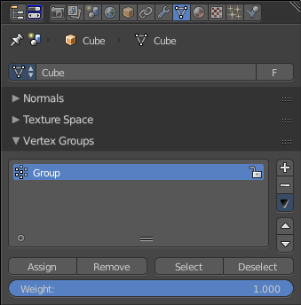
Vertex Groups
Vertex groups is a menu around vertex group functionality. The vertex groups can be found in the Object data tab in the Properties editor.

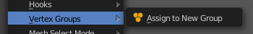
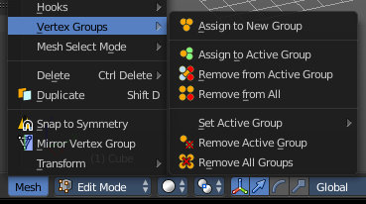
When there is no vertex group assigned yet then you can only see one menu item. The assign to new group button.
Once you have a vertex group assigned you will see the full functionality.

Assign to New Group
Assigns the mesh selection to a new vertex group.

Assign to active Group
Assigns the mesh selection to the currently active vertex group.

Remove from Active Group
Removes the mesh selection from the currently active vertex group.

Remove from All
Removes the mesh selection from all vertex groups.

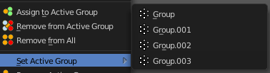
Set Active Group
Here you can select a vertex group to be the active one.

Remove Active Group
Removes the currently active vertex group.

Remove All Groups
Removes all vertex groups from the mesh.

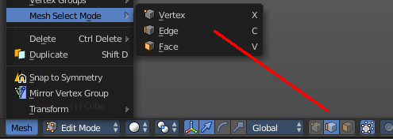
Mesh Select Mode
Mesh Select mode is a sub menu where you can set the current mesh select mode. Its functionality is equal to the mesh select mode buttons in the header. Just that you can't select more than one mode directly here. This menu exists to show and to edit the hotkeys. Not to work with it.
Interestingly the menu items have a last operator. Again, it is not meant to work this way. So this is just listed for documentation reasons.

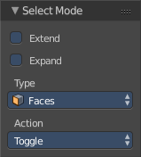
Last Operator Select Mode

Extend
Adds to the current selection mode

Expand
Not documented, not to find out, sorry.

Type
Here you can again adjust what select mode you want to activate

Action
How to work with the operator. Toggle means when you click at the button and it is disabled, then it enables. And vice versa. Enable and disable should be self explaining.

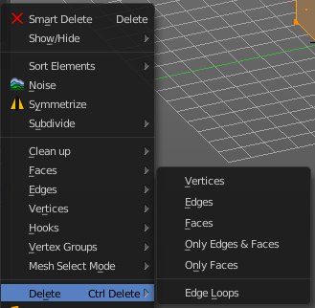
Delete
The smart delete works dependant of the selection and the mode. Which is fine for most cases. This delete menu gives you some more control over what exactly you want to delete. And how you want to delete it.

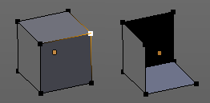
Vertices
Deletes the selected vertices, and all with it connected edges and faces.

Edges
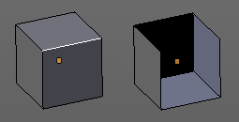
Deletes the selected edges and the connected faces.

Faces
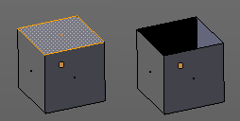
This one works similar to the smart delete. It deletes the selected faces.

Only Edges and Faces
This mode is of interest when you have more than one selection mode activated. It deletes then just the selected edges and faces. And not single vertices.

Only Faces
This mode is of interest when you have more than one selection mode activated. Just selected faces gets deleted. Not single edges or vertices.

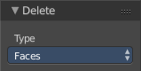
Last Operator Delete
The Last Operator Delete is the same for the above menu items.

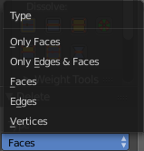
Type
Here you can choose the delete method again.

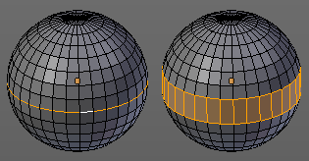
Edge Loops
This method works similar to the smart delete tool. It deletes the edge loop. But it selects the faces of the edge ring. And the Last operator offers you the option to split off face corners.

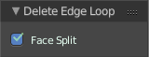

Last Operator Delete Edge Loop

Face Split
Split off face corners to maintain surrounding geometry.

Duplicate
Duplicates the current selection. The copy sticks to the mouse until you release it. A Right click while moving will reset the position of the duplicate. The duplicated part will be part of the same object.
When you drag the duplicate around you will see the position values in the header.

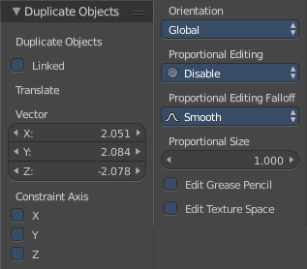
Last Operator Duplicate

Duplicate Objects

Linked
With this option ticked the duplication happens with linked data.

Translate
The Position of the duplicated object

Constraint Axis
Here you can limit the position relative to the source object.

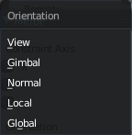
Orientation
Orientation is a drop-down box where you can choose the type of orientation for the mirroring action.

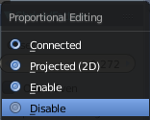
Proportional Editing
Proportional Editing is a drop-down box where you can choose to use proportional editing. When you choose one of the active methods then the neighbour geometry gets influenced by Shrink/Fatten too in a proportional way.

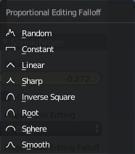
Proportional Editing Falloff
Proportional Editing Falloff is a drop-down box where you can choose a method for the falloff for the proportional editing.

Proportional Size
Proportional size is a edit box where you can adjust the strength of the Proportional falloff.

Edit Grease Pencil
Edit Grease Pencil edits the selected Grease Pencil strokes.

Edit Texture Space
With Confirm on Release checked the action gets performed when you release the mouse button.

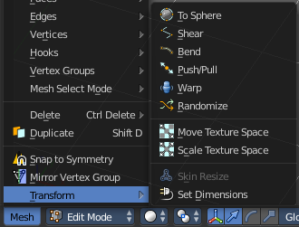
Transform
Transform is a menu that contains some special transform functionality.
See chapter Edit Mode - Transform Menu

Edit Mode - Curve + Surface Object - Curve + Surface Menu
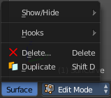
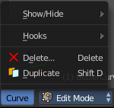
The Curve Menu in Edit Mode contains the tools to manipulate the curve geometry in Edit mode. It just exists for Curve Objects.

Same counts for the Surface Menu in Edit mode. The menus are identical since both object types are a curve type. So we handle both menus here.

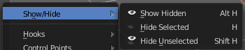
Show/Hide
Show/Hide is a menu. Here you can show or hide objects in the viewport. See chapter All Modes, all Object types - Show / Hide

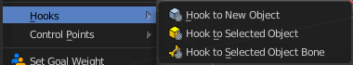
Hooks
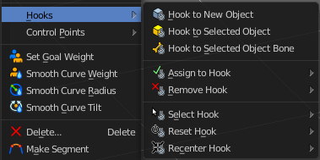
Hooks is a menu with tools around the hook modifier. You could also adjust the hook modifier from the Properties editor. But the menu items are more accessible.
When there is no hook modifier at the mesh then you just see three menu items. When there is minimum one hook modifier applied, then you will see an extended menu.

Hook to New Object
Creates a new Hook Modifier for the active object and assigns it to the selected vertices. It also creates an empty at the center of those vertices, which are hooked to it.

Hook to Selected Object
Does the same as Hook to New Object, but instead of hooking the vertices to a new empty, it hooks them to the selected object (if it exists). There should be only one selected object (besides the mesh being edited).

Last Operator Hook to Selected Object

Active Bone
Hook to the object(s) of the active bone.

Hook to Selected Object Bone
Does the same as Hook to New Object. But it sets the last selected bone in the also selected armature as a target.

Assign to Hook
Here you can assign the selected vertices to the chosen hook modifier. Existing hooks gets overwritten. One vertex can be assigned to more than one hook.

Remove Hook
Removes the chosen Hook Modifier from the object.

Select Hook
Selects all vertices assigned to the chosen Hook Modifier.

Reset Hook
Resets the chosen Hook Modifier.

Recenter Hook
Recenter the Hook Modifier.

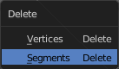
Delete
Delete calls a pop-up where you can choose if you want to delete vertices or segments.

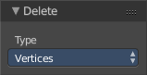
Last Operator Delete

Type
Here you can again choose if you want to delete vertices or segments.

Duplicate
Duplicates the current selection. The copy sticks to the mouse until you release it. A Right click while moving will reset the position of the duplicate. The duplicated part will be part of the same object.
When you drag the duplicate around you will see the position values in the header.

Last Operator Duplicate

Duplicate Objects

Linked
With this option ticked the duplication happens with linked data.

Translate
The Position of the duplicated object

Constraint Axis
Here you can limit the position relative to the source object.

Orientation
Orientation is a drop-down box where you can choose the type of orientation for the mirroring action.

Proportional Editing
Proportional Editing is a drop-down box where you can choose to use proportional editing. When you choose one of the active methods then the neighbour geometry gets influenced by Shrink/Fatten too in a proportional way.

Proportional Editing Falloff
Proportional Editing Falloff is a drop-down box where you can choose a method for the falloff for the proportional editing.

Proportional Size
Proportional size is a edit box where you can adjust the strength of the Proportional falloff.

Edit Grease Pencil
Edit Grease Pencil edits the selected Grease Pencil strokes.

Edit Texture Space
With Confirm on Release checked the action gets performed when you release the mouse button.

Edit Mode - Metaball Object - Metaball Menu
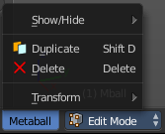
The Metaball menu in Edit mode contains the tools to work with Meta elements in Edit Mode.

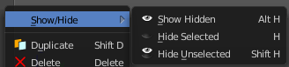
Show/Hide
Show/Hide is a menu. Here you can show or hide objects in the viewport. See chapter All Modes, all Object types - Show / Hide

Duplicate
Duplicates the current selection. The copy sticks to the mouse until you release it. A Right click while moving will reset the position of the duplicate. The duplicated part will be part of the same object.
When you drag the duplicate around you will see the position values in the header.

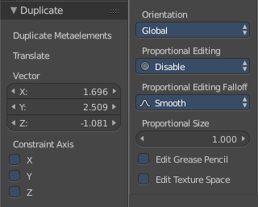
Last Operator Duplicate

Duplicate Meta elements
Just ignore this label.

Translate
The Position of the duplicated object.

Constraint Axis
Here you can limit the position relative to the source object.

Orientation
Orientation is a drop-down box where you can choose the type of orientation for the mirroring action.

Proportional Editing
Proportional Editing is a drop-down box where you can choose to use proportional editing. When you choose one of the active methods then the neighbour geometry gets influenced by Shrink/Fatten too in a proportional way.

Proportional Editing Falloff
Proportional Editing Falloff is a drop-down box where you can choose a method for the falloff for the proportional editing.

Proportional Size
Proportional size is a edit box where you can adjust the strength of the Proportional falloff.

Edit Grease Pencil
Edit Grease Pencil edits the selected Grease Pencil strokes.

Edit Texture Space
With Confirm on Release checked the action gets performed when you release the mouse button.

Delete
Deletes the selected element(s).

Edit Mode - Text Object - Text Menu
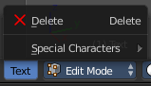
The Text menu contains the tools to work with text in edit mode.

Note that you have to use the Object mode box to escape the Edit mode with a text object. The hotkey to change the mode will be counted as text input for the text object.

Delete
Delete deletes the selected text.

To select parts of the text, move the cursor with the arrow buttons to the needed location, then hold down Shift, and select the letters by pressing the arrow buttons left or right. And then you can delete this selected text part.

Selecting text parts with the arrows brings up the Last Operator for Move Select.

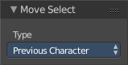
Last Operator Move Select

Type
Type is a drop-down box where you can change the selection method.

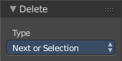
Last Operator Delete

Type
Type is a drop-down box where you can change the delete method.

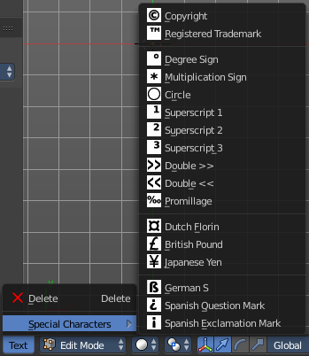
Special Characters
Special characters is a menu that contains some special text characters, like copyright, which you can insert into the text.

Edit Mode - Armature Object - Armature Menu

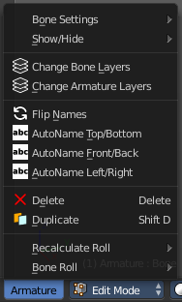
The armature menu provides you the tools to work with armatures and its bones in edit mode.

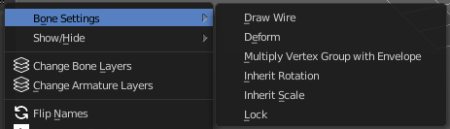
Bone Settings
Bone Settings is a menu with menu items to toggle special checkboxes in the Properties editor. But here you can do it for a selection too, and not just one object.

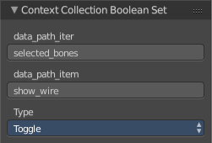
Last Operator Collection Boolean Set
Each of the menu items uses the same Last Operator. With different strings for the booleans.

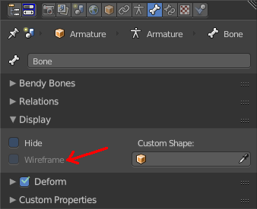
Draw Wire
Turns on or off the Wireframe checkbox, and so its functionality, in the Bones tab in the Display Panel Properties editor.
This checkbox requires to have a custom bone shape. It will not work at a normal bone shape. When you have a custom bone shape defined, then this custom bone object gets always displayed as Wireframe, regardless of viewport draw mode.

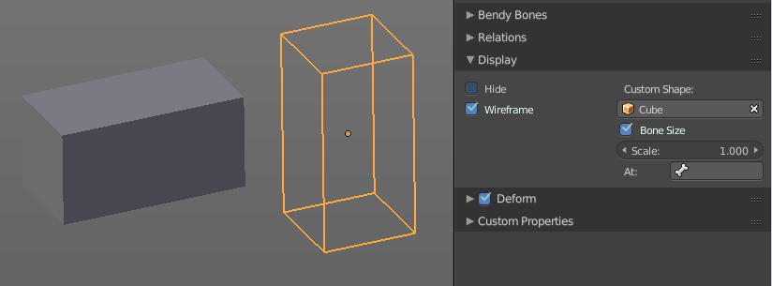

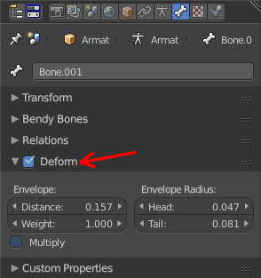
Deform
Turns on or off the Deform panel, and so its functionality, in the Bones tab in the Properties editor.
With Deform enabled the chosen bone deforms the connected mesh. The Deform panel also contains some Envelope settings.
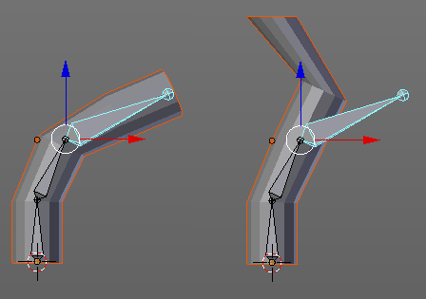

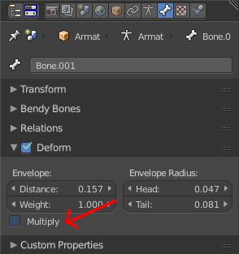
Multiply Vertex Group with Envelope
Turns on or off the Multiply checkbox in the Deform panel, and so its functionality, in the Bones tab in the Properties editor.
Multiply the effects of vertex group weights with envelope influence.

Inherit Rotation
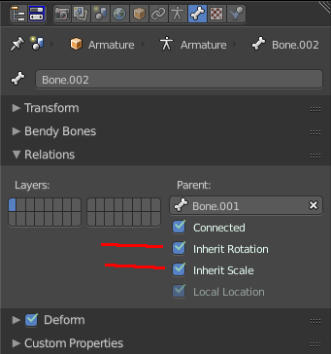
Turns on or off the Inherit Rotation checkbox in the Relations panel, and so its functionality, in the Bones tab in the Properties editor.
The bone inherits rotation from the parent bone.

Inherit Scale
Turns on or off the Inherit Scale checkbox in the Relations panel, and so its functionality, in the Bones tab in the Properties editor.
The bone inherits scale from the parent bone.

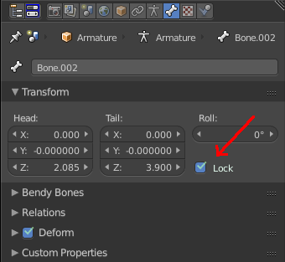
Lock
Turns on or off the Lock checkbox in the Transform panel, and so its functionality, in the Bones tab in the Properties editor.
Locked bones cannot be edited in edit mode anymore. They are locked.

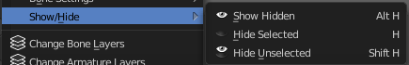
Show/Hide
Show/Hide is a menu. Here you can show or hide objects in the viewport. See chapter All Modes, all Object types - Show / Hide

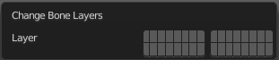
Change Bone Layers
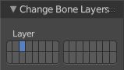
This menu item opens a popup where you can put single selected bone(s) onto another layer.

Last Operator Change Bone Layers

Layer
Here you can again put the selected bones onto another layer.

Change Armature Layers
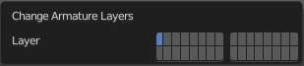
This menu item opens a popup where you can put the whole armature onto another layer.

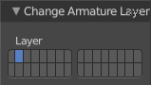
Last Operator Change Armature Layers

Layer
Here you can again put the armature onto another layer.

Flip Names
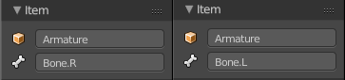
This tool requires to follow some name conventions. If there is a lower or upper case “L”, “R”, “left” or “right” with a separating dot in the bone name, then this tool renames the bones names to its counter part. Bone.L becomes Bone.R.
This tool is useful when you mirror parts of the armature, and don't want to rename all the bones one by one.

AutoName Top/Bottom
This tool automatically adds a suffix to all selected bones, based on their local position relative to the armature center.
Bones with a positive Z Coordinate will receive a .Top suffix. Bones with a negative Z coordinate will receive a .Bot suffix.

AutoName Front/Back
This tool automatically adds a suffix to all selected bones, based on their local position relative to the armature center.
Bones with a positive Y Coordinate will receive a .Fr suffix. Bones with a negative Y coordinate will receive a .Bk suffix.

AutoName Left/Right
This tool automatically adds a suffix to all selected bones, based on their local position relative to the armature center.
Bones with a positive X Coordinate will receive a .L suffix. Bones with a negative X coordinate will receive a .R suffix.

Delete Selected Bone(s)
Deletes the currently selected bones.

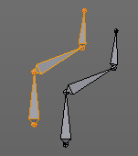
Duplicate
Duplicates selected bones. The duplicate is still part of the armature. The name number at the bones increases.
You are automatically in grab mode, and so you can easily move the object out of position. Which is sometimes wanted, since you can position the duplicate then. But sometimes this is unwanted. A right click after releasing the mouse lets the object snap back into its creation position.
When you drag the duplicate around you will see the position values in the header.

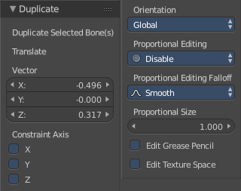
Last Operator Duplicate

Duplicate Selected Bone(s)
Just ignore this label.

Translate
Just ignore this label.

Constraint Axis
Here you can limit the position relative to the source object.

Orientation
Orientation is a drop-down box where you can choose the type of orientation for the mirroring action.

Proportional Editing
Proportional Editing is a drop-down box where you can choose to use proportional editing. When you choose one of the active methods then the neighbour geometry gets influenced by Shrink/Fatten too in a proportional way.

Proportional Editing Falloff
Proportional Editing Falloff is a drop-down box where you can choose a method for the falloff for the proportional editing.

Proportional Size
Proportional size is a edit box where you can adjust the strength of the Proportional falloff.

Edit Grease Pencil
Edit Grease Pencil edits the selected Grease Pencil strokes.

Edit Texture Space
With Confirm on Release checked the action gets performed when you release the mouse button.

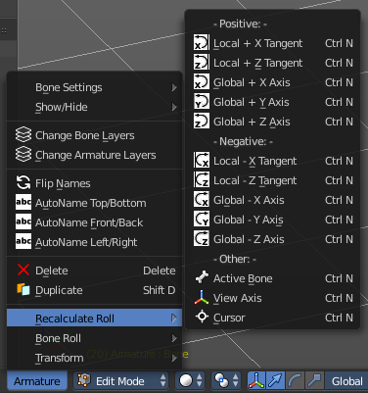
Recalculate Roll
Recalculate Roll is a menu where you can recalculate the bone roll in various ways.
The menu items are pretty self explaining. So we will not repeat the descriptions here.

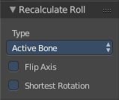
Last Operator Recalculate Roll

Type
Type is a drop-down box where you can choose the recalculation method again.

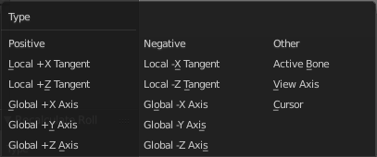
Flip Axis
Negates the alignment axis.

Shortest Rotation
Ignore the axis direction, and use the shortest rotation to align the bone(s)

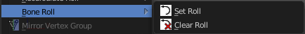
Bone Roll
Bone Roll is a menu where you can directly set the bone roll, or reset the bone roll to zero.

Set Roll
This operation is relative to the starting value, and starts always with zero. It does not display the Bone Roll value from the Transform panel. It adds or subtracts the amount of the operation to/from the Roll value then.
While operating you will see the current relative Roll value in the header.

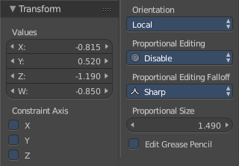
Last Operator Transform
The only interesting value is the X value right at the top. The other settings here are simply dysfunctional. You cannot turn on proportional editing, there is nothing to constraint, etc. . And so we will not go into detail here.
Unfortunately even the X value to display the amount of the roll is broken. It displays the amount in Radians, while the Bone roll is in degrees.

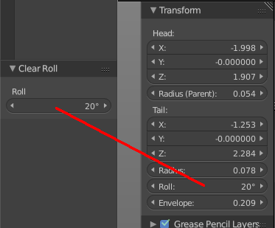
Clear Roll
Here you can set the bone roll value directly.

Last Operator Clear Roll

Roll
Here you can set the bone roll.

Edit Mode - Lattice Object - Lattice Menu
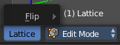
The Lattice menu provides you with tools to edit the Lattice object in edit mode.

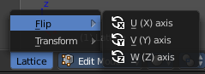
Flip
Flip is a menu where you can flip the lattice object along the world axis X, Y or Z

